Computing Systems assignment 3- Operating systems
Microsoft Windows
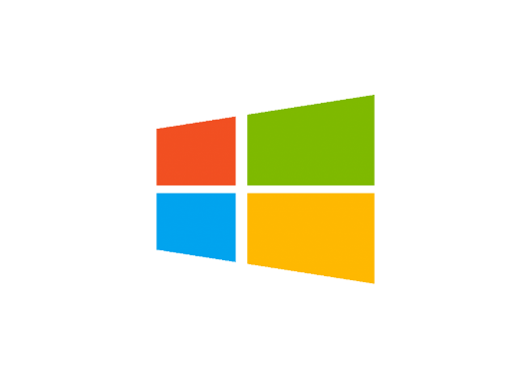
An operating system is a powerful program that manages and controls the hardware and the software of a computer. The one I will be discussing is Microsoft windows.

History and descriptions of Microsoft Windows
- Microsoft is a multinational company. Microsoft created Windows on November 20th, 1985. The Windows OS became the most dominant OS in the market with more than 90% of PC’s running on some version of Windows.
- Windows is available on 32 and 64-bit versions and offers many functionalities such as multitasking, memory management, support and more.
The following are the release dates for Windows,
- Windows 3.1 (1992)
- 95 (1995)
- XP (2009)
- 7 (2009)
- 10 (2015)
- 11 (2021)
Microsoft Windows has had a major impact on the world of technology more than any other OS. It was founded by Bill Gates and Paul Allen.


- Windows is an operating system created by Microsoft. Windows comes with a graphical user interface that displays a desktop with icons and a task bar that is at the bottom of the screen which allows quick and easy access to applications. Such as games photos and the store. Windows “file explorer” enables users to open several windows, browse folders, and access files and applications. It is a very clear and easy to use system as you can easily navigate and find applications in no time.
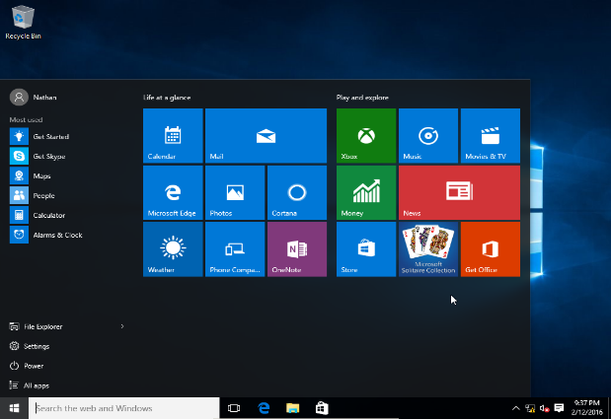

- Windows is an operating system for devices such as computers and tablets. It provides a way to stores files, run software, watch videos, play games and connect to the internet. Windows is the preferred OS due to its abundancy of tools and features and most laptops come with a pre-installed Windows system and free updates.
- Windows has a built in mechanism to keep the software updated which ensures you are up to date with Microsoft Windows ensuing maximum efficiency.

Process Management
Process management is a vital part of Windows. It assigns resources so that the processes can share and exchange information. Process management includes several tasks such as creation, scheduling, terminating processes and dead lock while also protecting resources from each process.
How does Microsoft Windows implement process management?
- Schedule processes and threads on the CPUs.
- Create and delete user and system processes.
- Suspend and resume processes
- Provide mechanisms for process synchronization
- Provide mechanisms for process communication

- Creation: process is created, it joins the queue which is the main memory and it will then be ready for the execution.
- Scheduling: a process is selected by the OS and starts executing it from the ready queue. Choosing the process that will be executed next is called scheduling.
- Execution: as soon as the process is scheduled for execution, the processor begin to execute. If the process becomes blocked while the execution is taking place then the processor will begin to execute different processes.
- Deletion: when the purpose of the process is finished, the OS will delete the process. The content of the process will be deleted and the process gets removed by the OS.
Schedular: is the part of the kernel in charge with the strategy for allocation/de-allocation of the CPU. It determines which process will use the CPU next, and how long that process has to run. It maintains a record of all processes in the OS (using a process table), introduces new processes to the pool and removes completed ones. The dispatcher is a component of the kernel that oversees the execution of the scheduled processes. This is achieved by multiprogramming. It performs a process switch to change from one process to another.
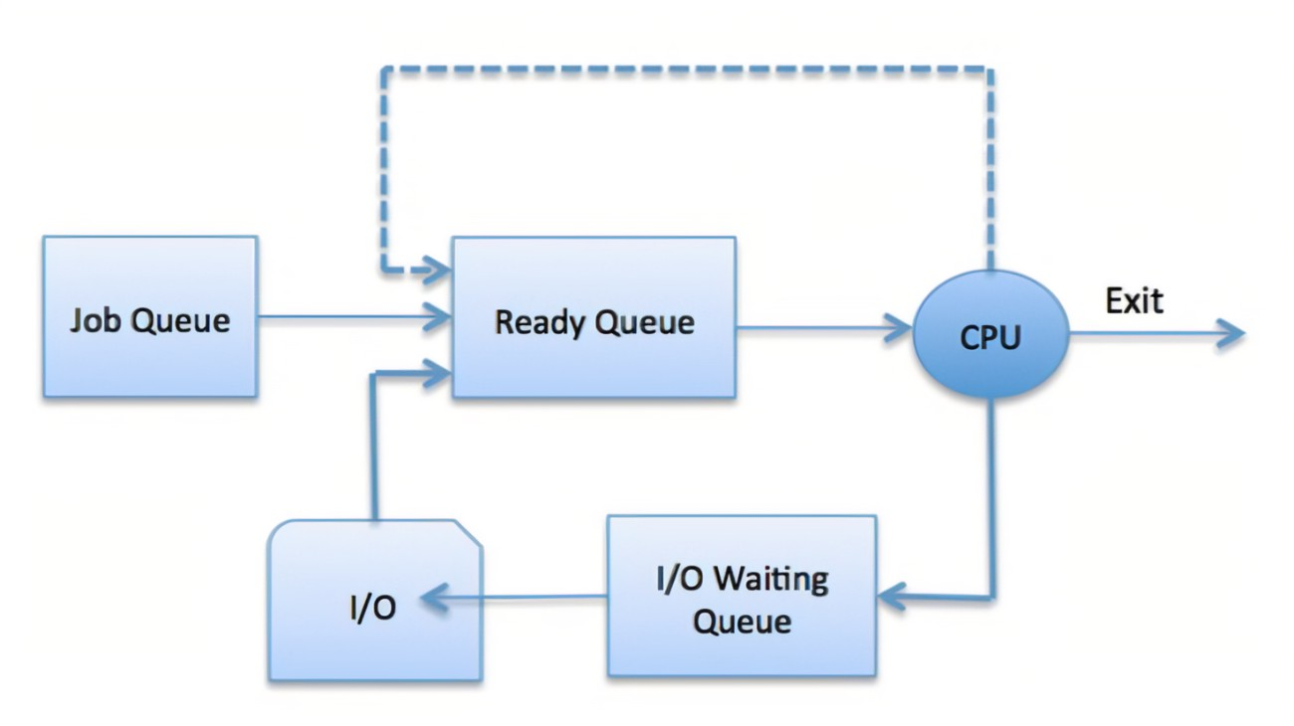
Deadlock: where a set of processes have been blocked because each of the processors holding a resource and creating competition for non-sharable resources. For example if two trains are on the same track in opposite directions, none of the trains can move. This compares to when two or more processes holding resources and wait for other resources held by others.
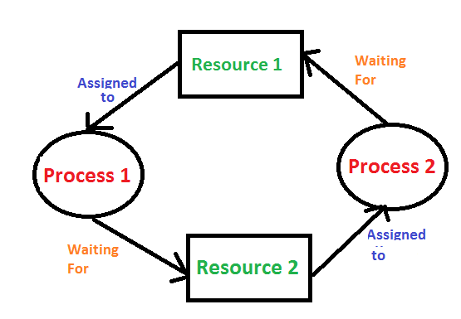

Memory Management
The process of controlling and coordinating the computer’s memory. It assigns portions known as blocks to various running programs ensuring there is maximum performance of the OS.
How does Microsoft Windows implement memory management?
The Windows memory management allows processes to keep moving back and forward between the main memory and execution disk. It helps the OS to keep track of memory location. It can also track the memory that remains free.
Why do we use memory management?
- To check how much memory is needed to be allocated to different processes. Deciding which processor should get memory when and at what time
- Track inventory
- Allocate space to application routines and ensures of no interference between applications
- Protect processes from one another
- Places programs in memory so it is used to its full capacity
Some memory management techniques include:
- Single contiguous allocation: All types of the computer memory is reserved for the OS and is available for one application. A small percent is not reserved
- Partitioned allocation: The memory is divided into various memory partitions. These store all information for jobs and specific tasks.
- Paged memory management: Divides the computer’s main memory into fixed-size units called page frames. It retrieves memory from a secondary storage so it can then be used in the main memory.
- Segmented memory management: is the division of a computer’s primary memory. It does this by dividing into sections in the form of a segment table.

File Management
the process of manipulating files in a computer system, its management includes the processes of creating, modifying and deleting files.
How does Microsoft Windows implement file management?
Microsoft Windows offers a built-in file explorer for file management. You can easily access the stored contents on your disk drive.
Objectives:
- Provides input/output support for storage devices
- Minimise chance of lost or destroyed data
- Helps OS to standardized input/output interface routines for processes
- Provides input/output support for multiple users.
File structure:
- text file
- objective file: series of bytes that is organised into blocks
- source file: a series of functions and processes
File attributes:
- Name
- Identifier: unique tag number
- Location
- Type
- Size
- Protection
- Time, date, security
File operations: are the various task windows performs on files. These operations can be performed by using the commands provided by the operating system.
Operations include:
- Create
- Save
- Open
- Modify
- close
- Rename
- Delete
Access permissions: Windows file access permission helps set down the means in which a user can access a file. These are the access rights that allow us to read, write or execute a file.
Permissions include:
- read only
- write/modify the content
- execute/run
File system: stores and organizes files and their information on a hard disk.
- File allocation table: used to organise files and folders in the form of a table(FAT). This system is used for disks that are smaller in size and contain simple folder. Examples: FAT12, FAT16, FAT32
- New technology file system: developed for large files to carry out functions of basic file operations such as reading, writing, modifying and saving.

Device Management
Responsible for managing all the hardware devices of the computer system. It may also include the management of the storage device as well as the management of all the input and output devices of the computer system.
How does Microsoft Windows implement device management?
Main functions:
- Tracks the devices and program, this is called input/output controller.
- Monitor the status of every device.
- Enforces pre-established policies and decides which process gets the device and for how long.
- Allocate/de-allocate devices
- Boost performance of individual devices.
Device Types: Windows uses various devices to execute the main duties of device management.
- Dedicated devices: assigns to one job at a time until that job is complete, this applies to devices such as printers since only one user can instruct the printer to carry of its function at one given time.
- Shared devices: these devices can be assigned to multiple processes.
- Virtual devices: these are dedicated devices which can be converted into shared devices

Features of device management:
- The OS interacts with the device controllers via the device drivers while allocating the device to the multiple processes executing on the system.
- Device drivers can be thought of as system software that bridge processes and device controllers.
- The device management function’s other key job is to implement the API
- Device drivers are software programs that allow the Windows operating system to control the operation of numerous devices effectively.
- The device controller used in device management operations mainly contains three registers, command, status and data.

References:
J Glenn Brookshear “Computer Science – An Overview”, ISBN: 0-321-54428-5
Microsoft Windows | History, Versions, & Facts | Britannica
https://guru99crack.com
https://www.geeksforgeeks.org
https://www.javatpoint.com/

